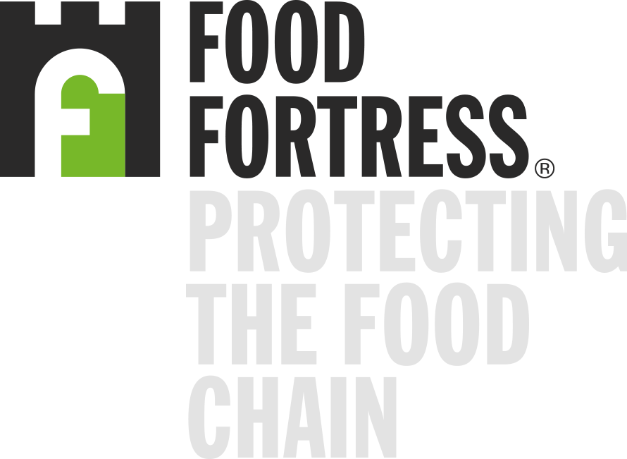
Galloway & MacLeod
is a full member of the Food Fortress contaminant surveillance program for animal feeds.
Signed
Robin Irvine  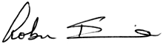  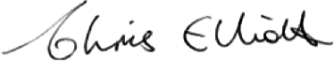  Director of Food Fortress | Professor Chris Elliot    Pro Vice Chancellor  Faculty of Medicine,  Health & Life Sciences
Dated
1st July 2024 (valid for 12 months)

